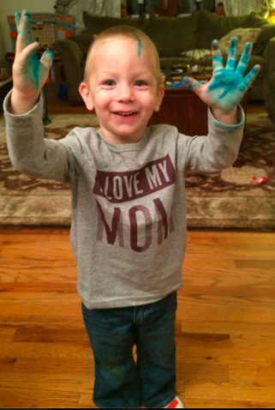

**Math**

The students will continue working with Chapter 2 this week. Our focus will be on fractions, decimals, percent and converting between the 3. Those pesky multiplication facts are coming up again, it may be worth it to practice those if needed!

**Social Studies**

This week we will continue with our discussion on thematic maps. The students will investigate political and climate maps this week. This will also lead into our discussion on how geography affects culture.

**Science**

The students will spend the majority of their science periods this week discussing their Wisconsin Fast Plant experiments. We will harvest and thresh our seeds on Monday! The students will then work in groups to discuss their results and conclusion and answer their experimental question.

It is very important that you finish your Seedfolks final project at home if you did not finish in school. Students were given 2 weeks of our Reading time (and Flex) to work on a Tic–Tac-Seedfolks project. During this time students were expected to choose 4 assignments to complete as a culmination of our class book. Final projects are due on Monday, therefore if they are incomplete, they should be finished at home to be given credit.

Look Mom, I found permanent marker!

# Writing – This week the students finalize and publish their personal narratives. We will have a celebration on Thursday to celebrate the end of our first Writer’s Workshop unit! We will celebrate in our “Coffee-Shop” manner with mugs of hot cocoa and breakfast treats. Feel free to bring anything in to help us celebrate!

# Reading – Contrasts and contradictions will be the focus of our reading lessons this week. We will also begin our new read-aloud book Hatchet this week!

* Seedfolks finalized project due on **Monday, Oct. 16th**
* Fire Prevention and Safety assembly on **Wednesday, Oct. 18th**
* Final published personal narratives memoirs are due on **Thursday, Oct. 19th**
* Personal narrative share and “Coffee-Shop” celebration will be on **Thursday, Oct. 19th**

### Important Dates

A Note from Mrs. Biancardi

Classroom News

Room 28

October 16th – 20th