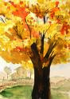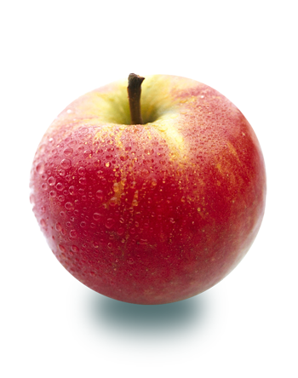

# Writing

# The students will dedicate time this week working towards their individual writing goals, using the narrative writing checklist as a guide.

# Math

# The students will take another quiz on Chapter 1A on Monday. After reviewing the quizzes taken on Wednesday, I have concluded that many student errors occurred from not reading directions carefully. In order to help boost their grade, they will have another opportunity to take the quiz on Monday!

**Important Dates:**

Math Chpt. 1A Quiz (2) Oct. 2nd

Parts of Bee Quiz Oct. 3rd

Soman Chainani Visit Oct. 5th

Picture Day Oct. 5th

Progress Reports Oct. 6th

Just wanted to review the homework policy for Room 28 with all quickly! If a student comes to school with missing and/or incomplete homework the student will receive a homework stamp for missing homework in their assignment book. A lunch/recess detention will be given to students with 3 stamps in the same subject per marking period. Parents when reviewing assignment books, be on the lookout for stamps!

### A Note from Mrs. Biancardi

The students will wrap up Chapter 1 this week in their Geography Alive textbooks. Our last lesson will be on map projections.

This week in Science we will wrap up our plant study with a look at our results and conclusions of our experiment.

The students will work on a culminating activity for the book Seedfolks this week.

#### Reading Science Social Studies

October 2nd- 6th

Classroom News

Room 28