Math Study Guide
Test on Wednesday, October 19
Key Vocabulary
Divisor
Dividend
Quotient
Key Concepts (Students must be able to:)
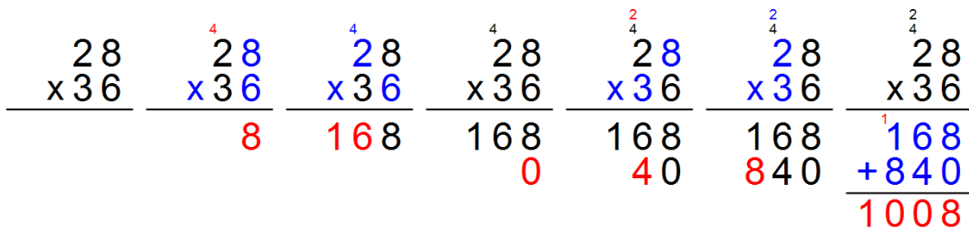
Multiply multi-digit numbers

Distributive property of multiplication
Ex. 148 x 3 = (100 x 3) + (40 x 3) + (8 x 3)
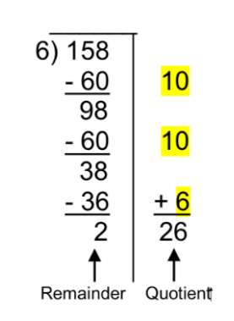
Divide using partial quotients strategy

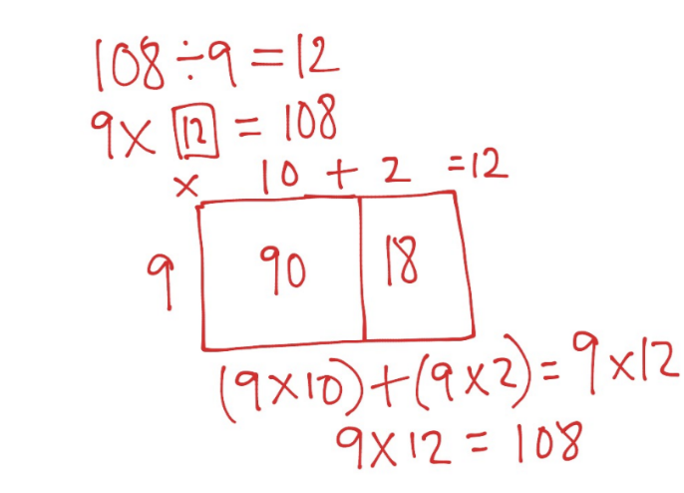
Divide using inverse operations and the area model

Solve multi-step word problems using addition, subtraction, multiplication, or division

